**CSE-326**

**INTERNET PROGRAMMING LABORATORY**

**Final Report**

**Group: 3**

|  |  |  |  |
| --- | --- | --- | --- |
| **S.NO** | **REGISTRATION NO** | **NAME OF THE STUDENT** | **ROLL NO** |
| 1 | **11908751** | AMAN PATRA | A07 |
| 2 | **11908774** | AMAN KUMAR | A08 |
| 3 | **11908797** | SAHAJ PREET SINGH | A09 |

  **Submitted to**: Mr. Ishan Kumar

**INTRODUCTION:**

Project was basically about a property website in which modules were given according to the website. The title of the website is **The Realtors.** The website has functions or modules like **Buy, Sell, Rent, Sign up, Contact us and Gallery.** There is a logo with the name The Realtors and a slogan “We value people’s emotions not transactions.” In the website you can buy, sell or rent any kind of property. The website also has some photos of some different kind of properties to have a look on our work.

**Role of each student in the website:**

**Name:** Aman Kumar **Roll no:** A08 **Regno**: 11908774

He made the buy page that will open on clicking the buy button. He added background images and a table of uploading the details of the buyer and the type of property we wants. He also made the Sell page that will redirect when user clicks on the sell button with a background image and fill up table with user details. He added a feature of uploading the pictures of the property if someone has to sell or give it on rent that’s give a very original look to the website.

**Name:** Sahaj preet singh **Roll no:** A09 **Regno**: 11908797

He made the home page of the website. First he designs the home page of our website and then he adds following pictures, divisions, classes and tags to make our website attractive. He also made up the signup page that will open on clicking the signup button in the homepage. He add background image on the signup page and also a signup table for the user. He also added a feature of sign up with facebook in the signup page. He also searched about many tags that were very useful to make our website more attractive. . He made the external Css file for the styling of our website with name ”style.css”.

**Name:** Aman Patra **Roll no:** A07 **Regno**: 11908751

He made the rent page that will open on clicking the rent button on the home page with wonderful background image and a fill up table for user and he also helps in making the last part of the homepage. He also helps in making the table of for the pages. He downloaded all the pictures used in our website. He also helps in making the logo of the website.

At the end we all three worked equally in our project. The design of the project was made with everyone’s ideas as we combine all the ideas of each other and frame it into one. Styling ideas i.e. color, padding, width, font size and other features are also done with the combined ideas of each other.

**Tags used in our website:**

* Header tag <header>
* Image tag <img>
* Button tag <button>
* Division tag <div>
* Paragraph tag <p>
* Styling tag (bold tag)(underline tag) <b><u>
* Heading tag <h1>
* Reference tag/linking tag <a>
* Body tag <body>
* Tag for line break i.e. <br>
* Form tag <form>
* Input tag <input>
* Span tag <span>
* <hr> tag for a horizontal line
* Style tag <style>
* Title tag <title>
* Link tag <link>
* Html tag <html>
* Head tag <head>

**Screen Shots of our websites home page:**

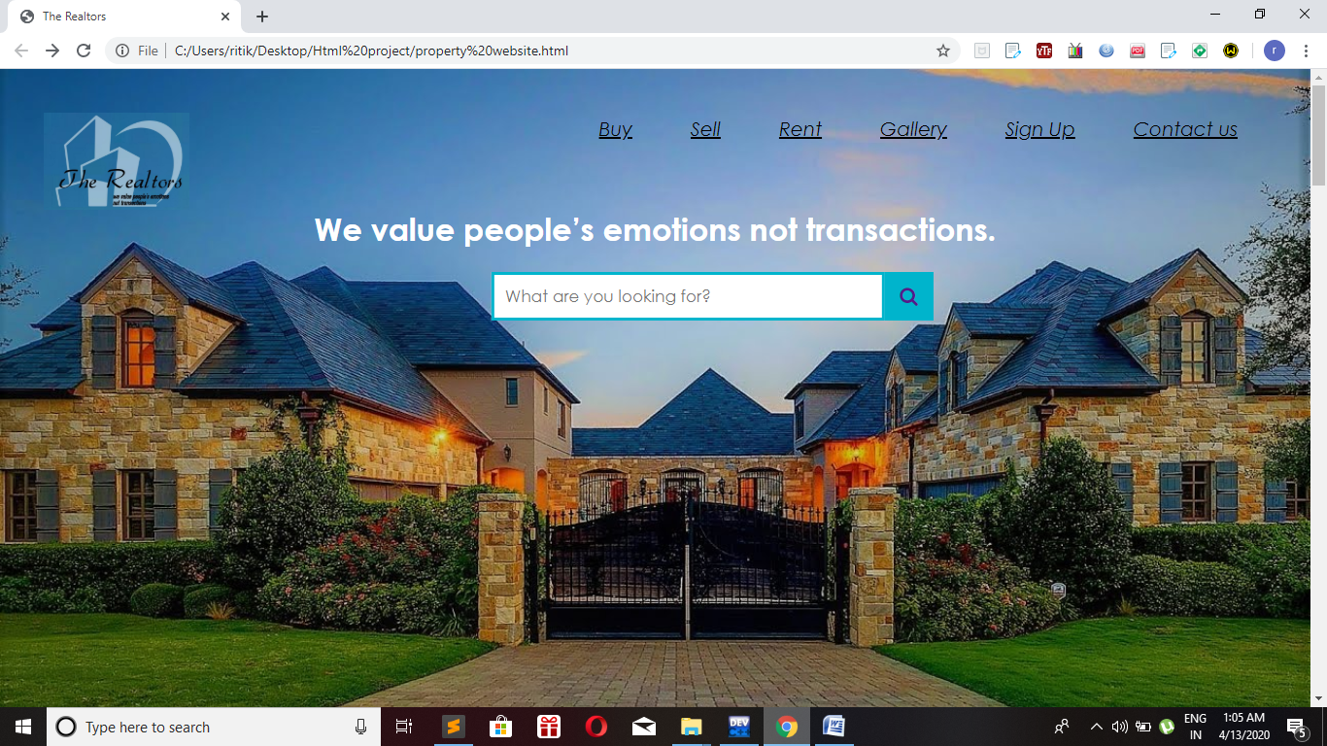

**This is starting view of our home page with buttons, logo, search bar and background image.**

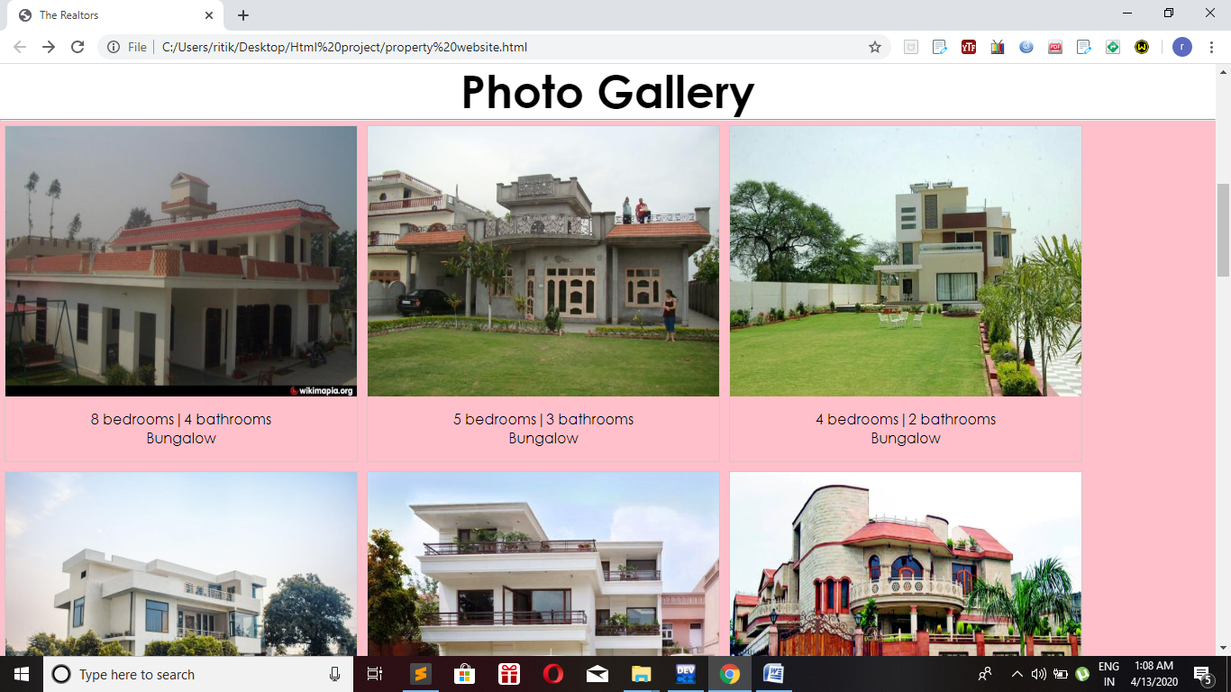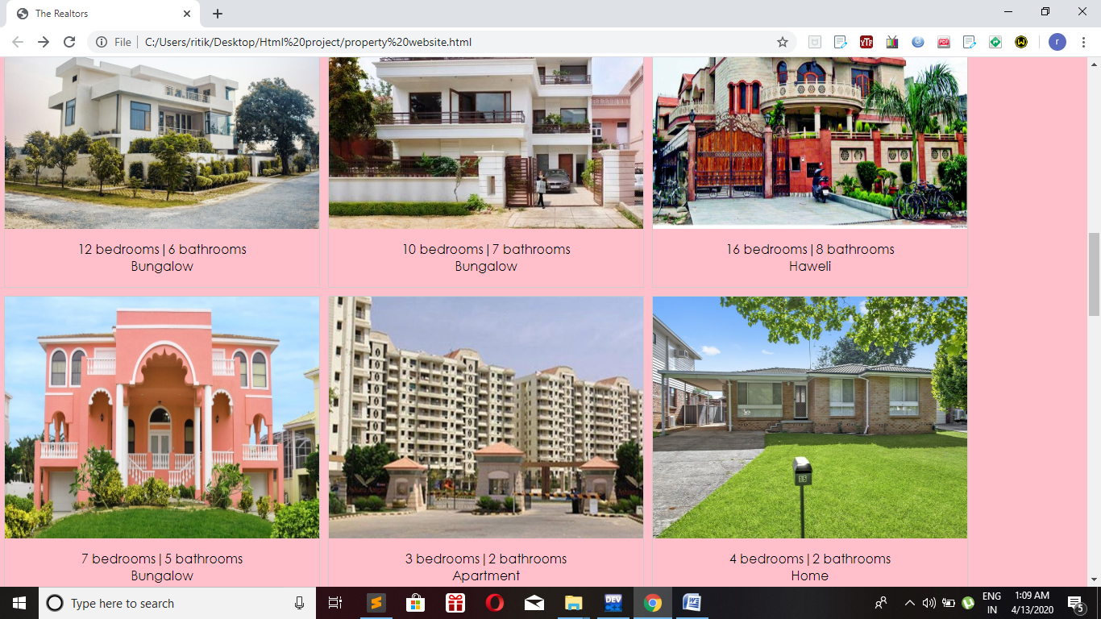

**This is the view of the photo gallery in our website.**

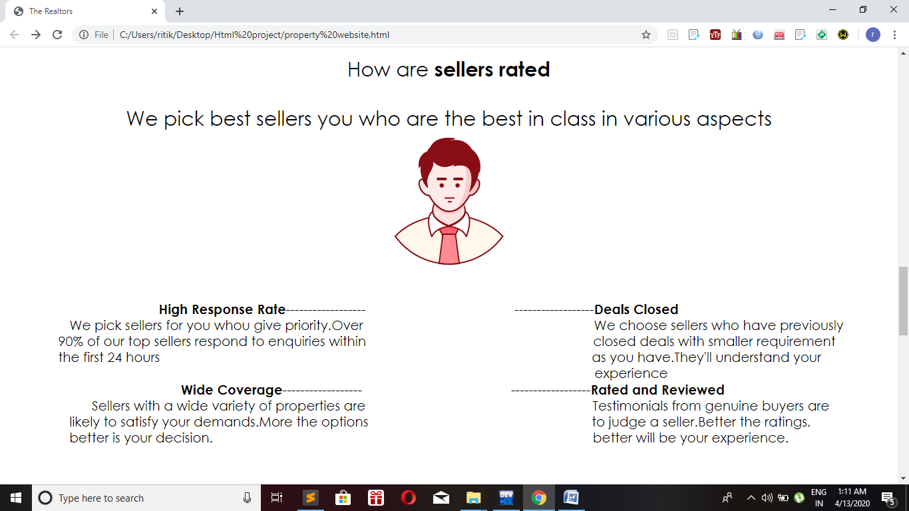

**This is a division in our website in which we tell the user how we rate the seller.**

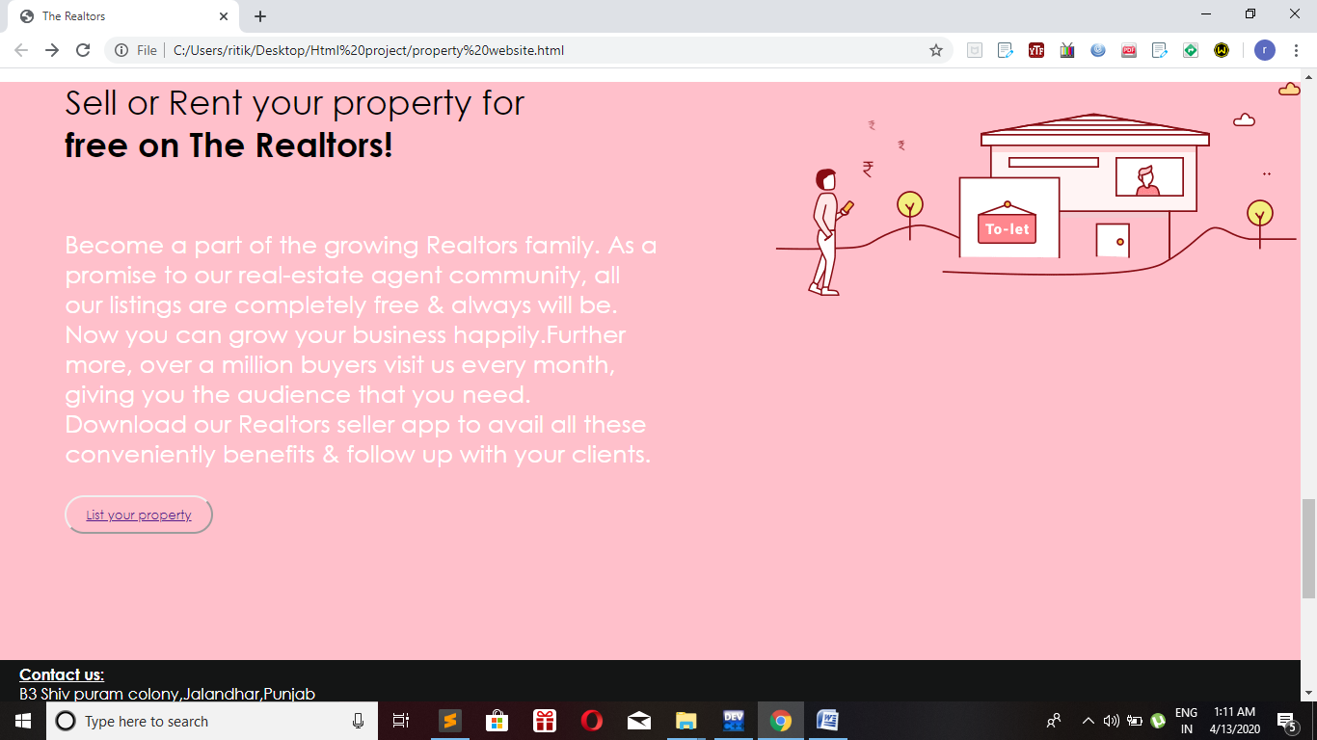

**This is a division in our website for selling or puttong property on rent.**

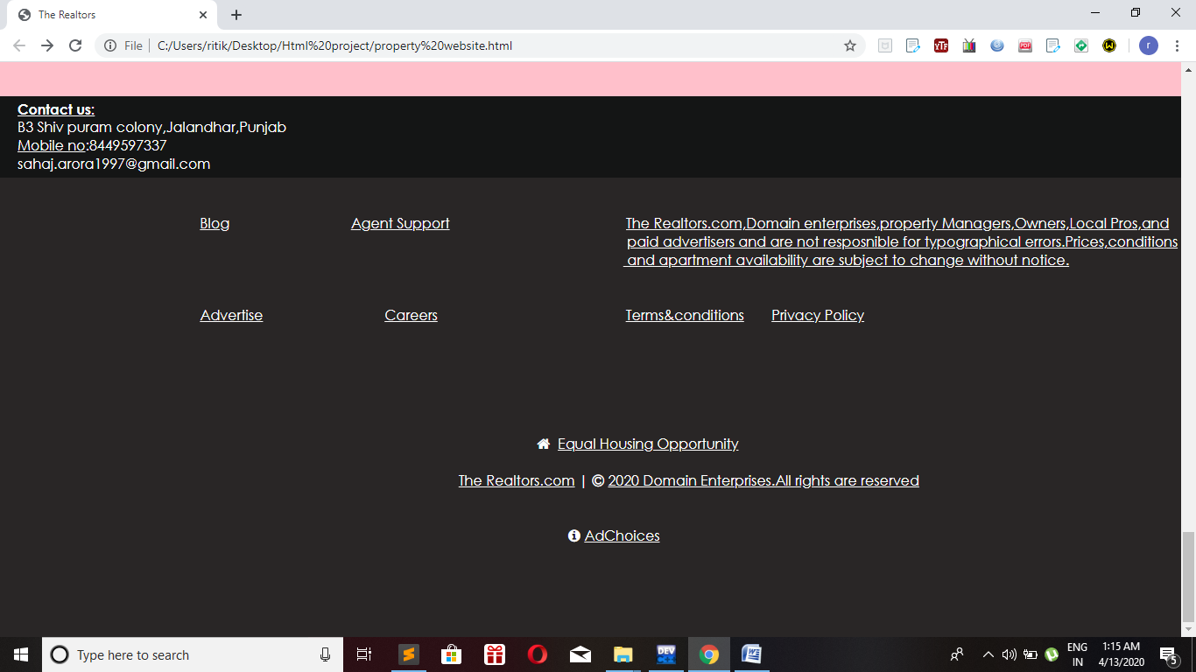 **This is a division having contact us part and also the ending of the website in other division.**

**Screen Shots of other pages of our website: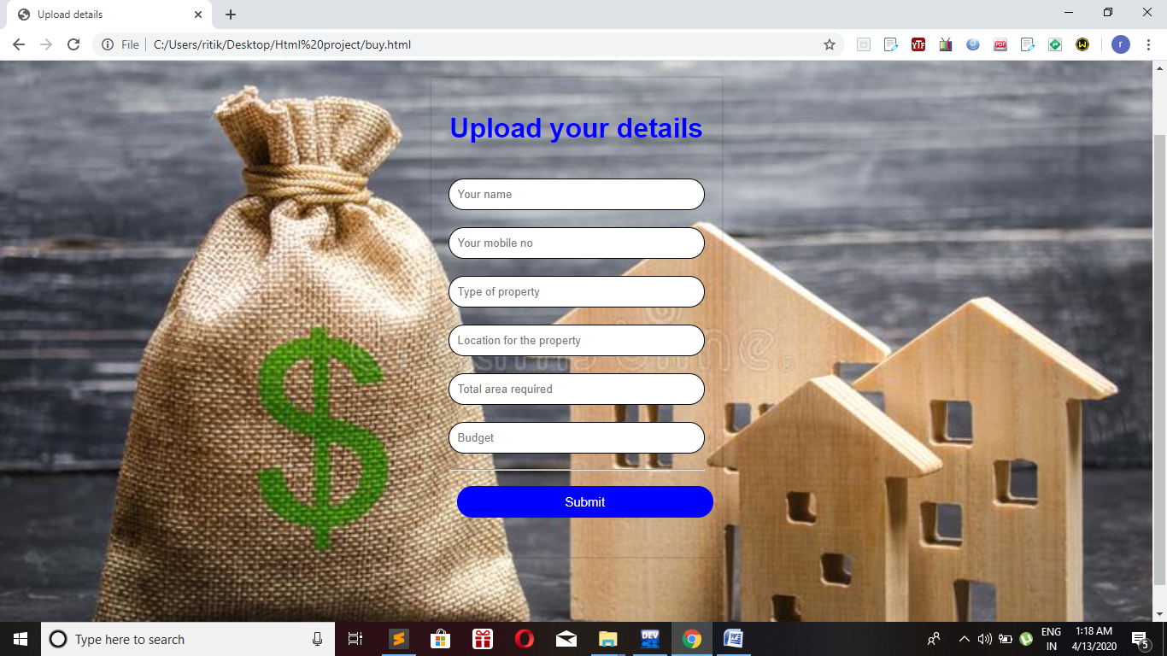This is our buy page open on clicking the buy button.** 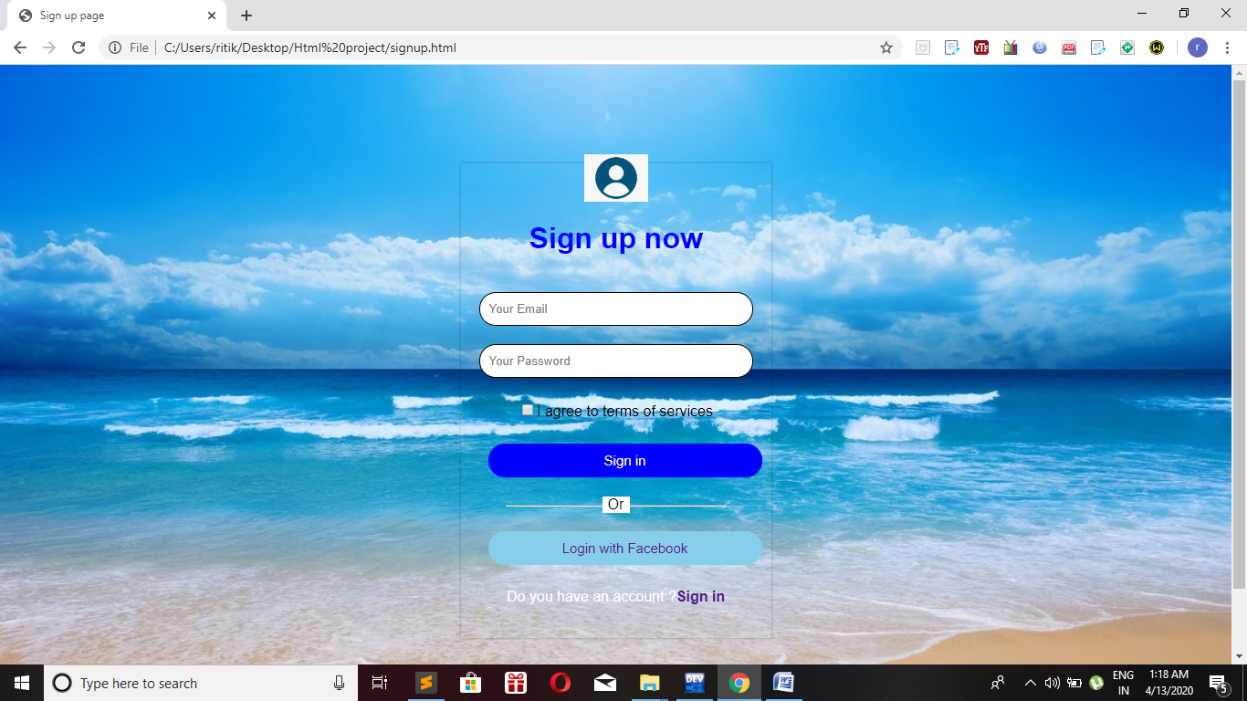

**This is our signup page open on clicking the signup button.**

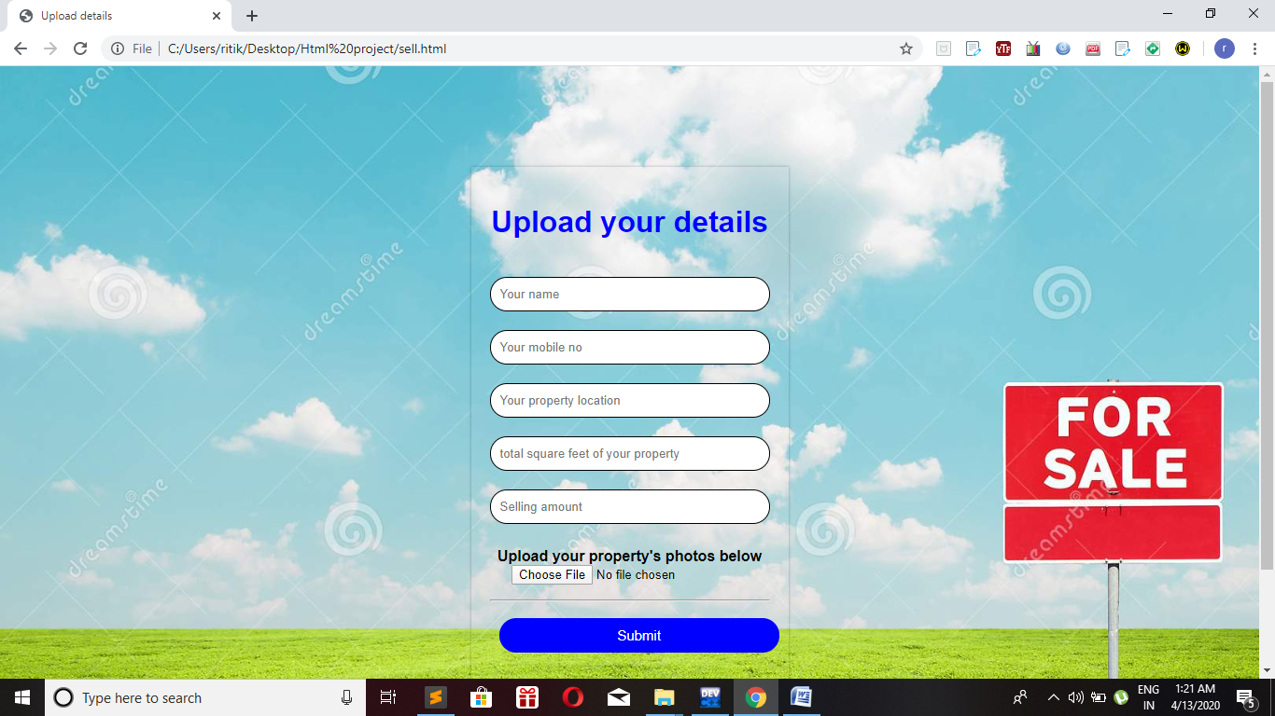

**This is our selling page open on clicking the sell button**

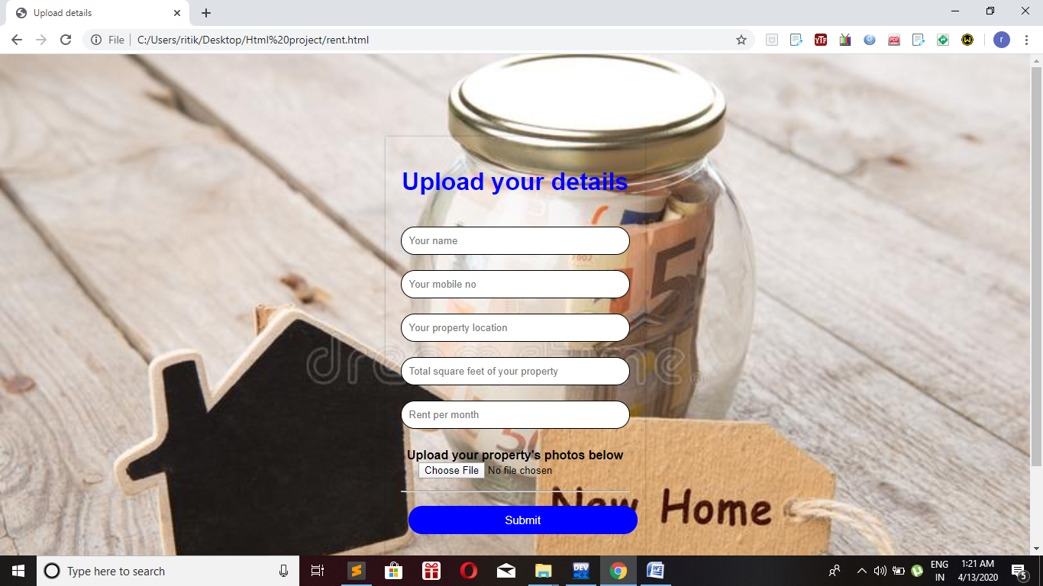

**This is our rent page open on clicking the rent button**